Hiscox University Data Challenge 2018

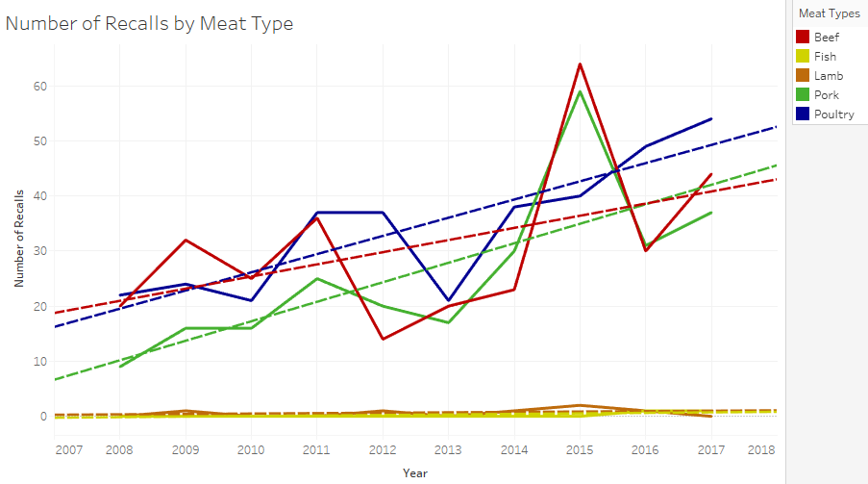We elected to focus on meat data, from the USDA, as this was the most comprehensive data set; furthermore, with the rise of veganism but an overall increased demand for meat products in the global market, we believed focusing on meat products would be an excellent area of study.

From section one of the project, we saw the number of recalls for the 3 most popular meats: beef, poultry, and pork have increased over time. However, that’s not the whole story; the total amount of meat produced has also increased, year on year. As a result, our query should be ‘are said recall escalations in line with production rises?’ and ‘has an increase on demand lead to more or less failures within the industry?’

NB) The year 2008 has been removed from the dataset, due to the anomalous nature of that year. This is most likely caused by the Hallmark/ Westland beef recall [1]; this is mentioned later in the report. The 2 peaks in poultry recalls are likely caused by: Cargill recalling 36 million pounds of ground turkey (2011) [2] and The National Steak and Poultry establishment recalling 1.9 million pounds of ready-to-eat chicken (2016) [3].

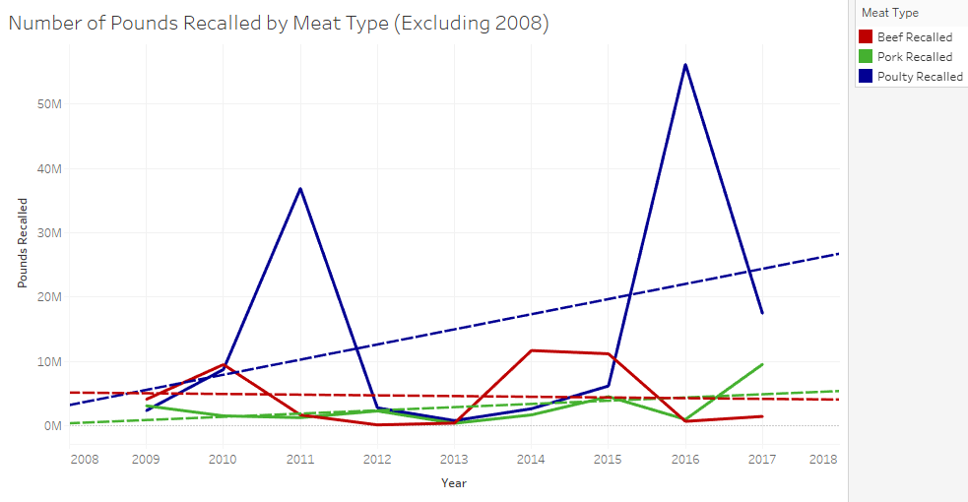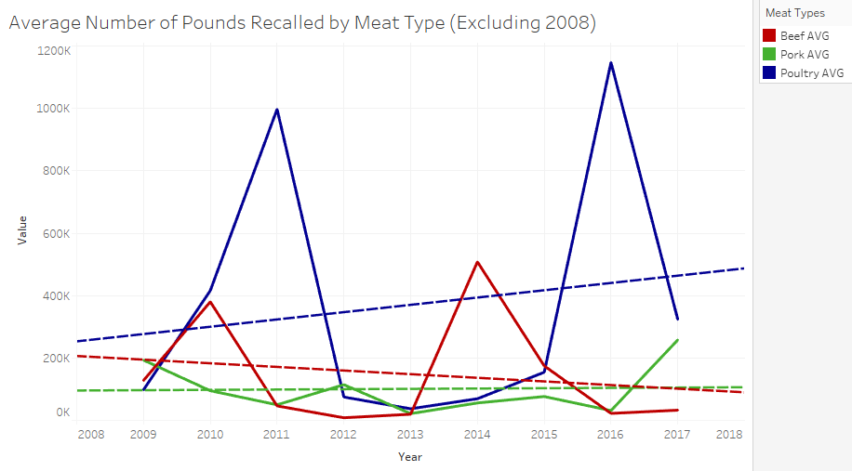

From the surrounding graphs we begin to see a more comprehensive view of the dataset.

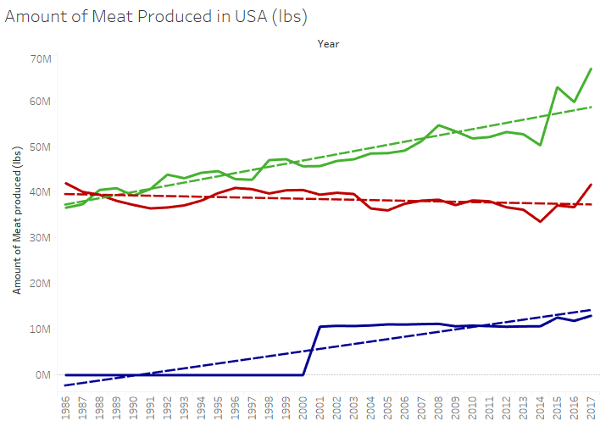

NB) Production figures for chicken/poultry was unavailable prior to 2001, as such the trend line is significantly flatter than the indicated line.

The increase in pork production (shown left) may show a relatively stable investment; despite the increase in production, and therefore an increased potential for more/larger sized recalls, the number and size of recalls have remained constant (if not having fallen slightly). This potentially indicates a more predictable and therefore safer insurance investment.

Beef’s slight reduction in average size of recalls may be attributed to the decreasing volume of beef being produced. This may indicate a stable insurance investment when ignoring Hallmark/Westland beef recall. Further analysis would need to be done to determine if the decline in recalls is equal to the decline in manufacturing.

Figure

The data indicates poultry is a more volatile product, contributing two relatively major recalls in the past 10 years. As a result, this indicates a riskier insurance investment; it would require a higher excess rate or a more carefully chosen upper limit on pay-out, in the event of a recall.

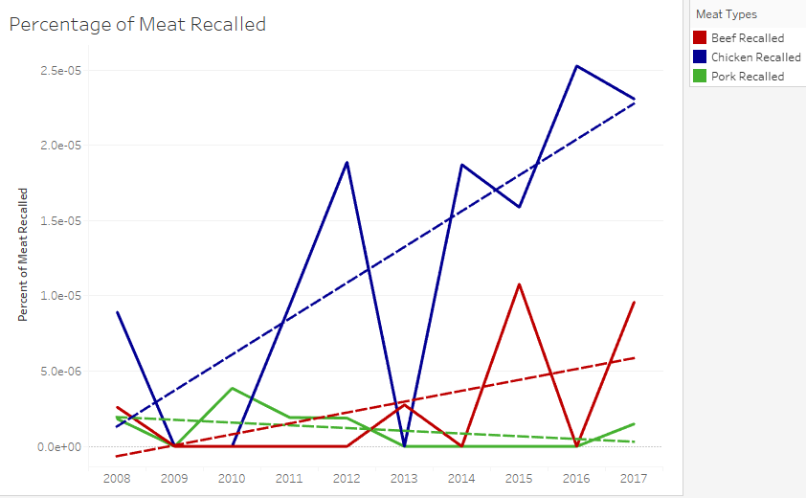The left graph verifies these possible assertions. In recent years the proportion of beef and chicken recalls have increased, while the proportion of pork recalls have fallen. Coupled with an increased variation around trend lines this indicates poultry and beef products may be becoming riskier investments and pork may be becoming a safer option for insuring.

Although past figures can provide us with an insight on how to estimate the probability and cost of a recall, we believe that it is possible these particular statistics do not fully indicate trends in the near future. Observing ‘Figure 1’, from 2014/15 onwards, we can see a small increase in the production of the 3 major meats.

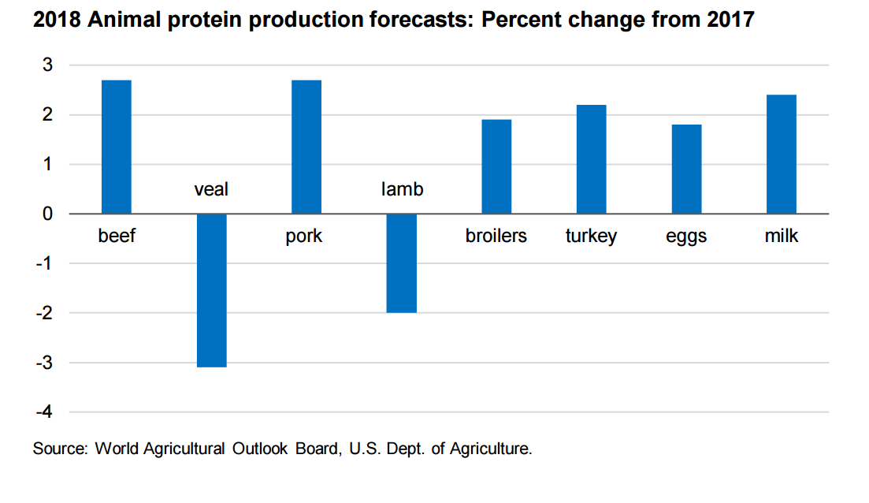On its own this slight twitch would be unlikely to mean much; however, source [4] states beef, pork and chicken production are predicted to increase between 2-3% on 2017 figures.

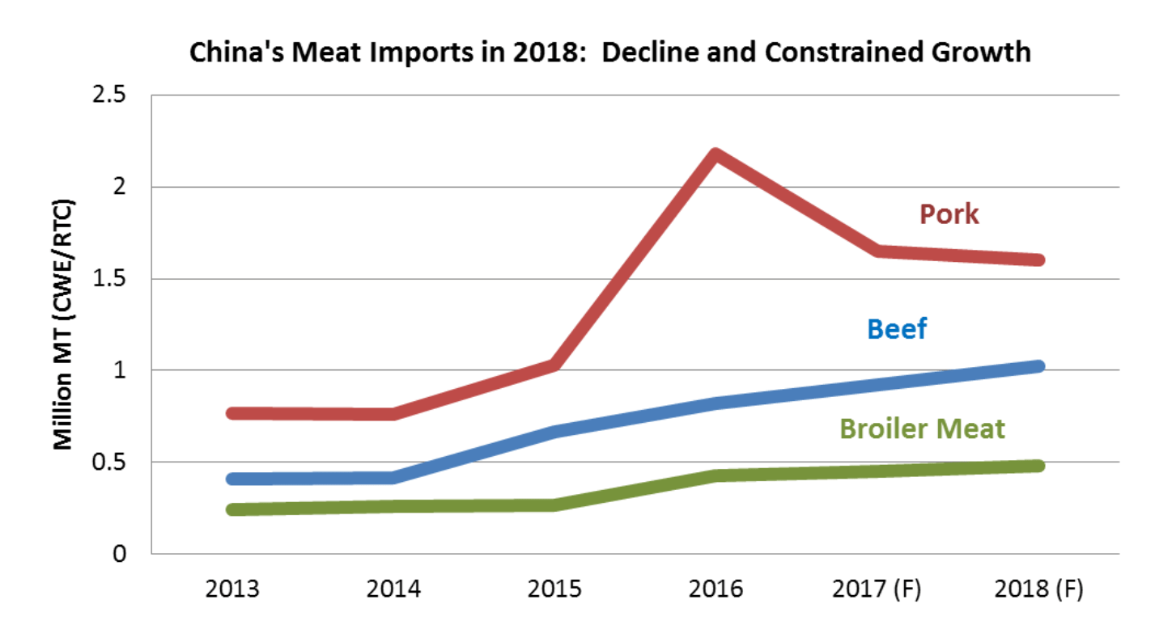This increase in production seems surprising, given the rise of veganism from 1% to 6% of the population between 2014 and 2017 [5]. Furthermore, source [6] seems to indicate the potential reduction in US meat markets, with millennials spending less on meat products than previous generations. Conversely, this trend may not be fully reflective of the scenario, as pastas are typically associated with the skint student stereotype; hence, millennials may ‘grow out of’ this eating habit once they begin work and have more liquid assets.

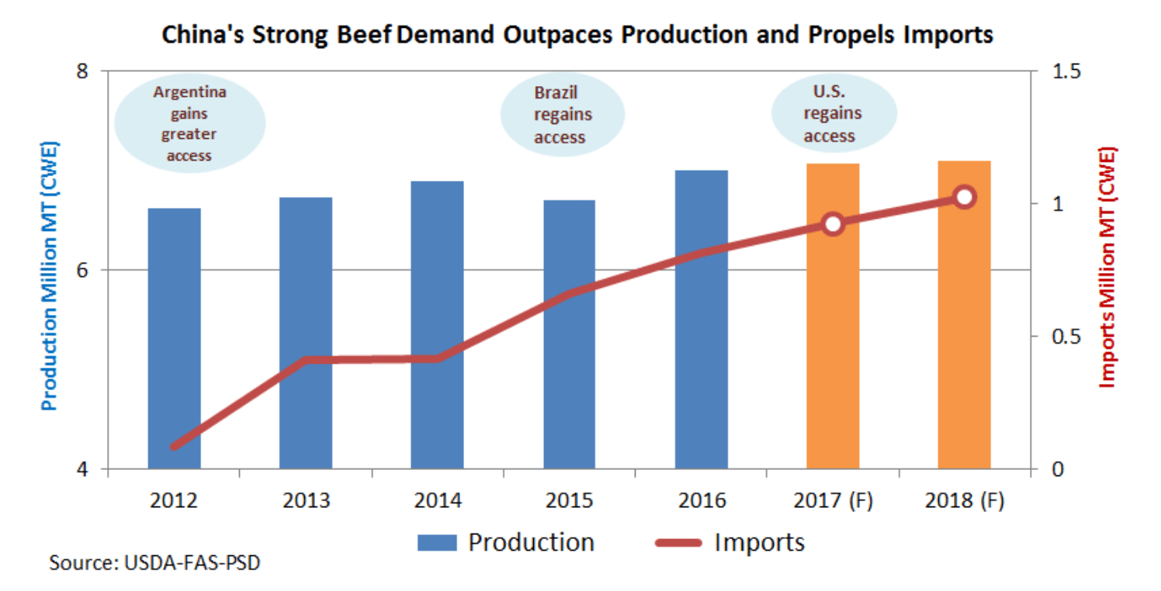The previous arguments would indicate a decline in the US meat industry, if not for China’s increase in demand for meat products; China is becoming a wealthier nation, with a growing appetite for meat. China is the second largest importer of beef and seventh largest importer of broiler chicken. Predictions state Chinese imports of broiler meat and beef, will rise to 13% and 5% of the global market respectively [7].

This demand, and relatively recent trade deals offer new opportunities for farmers, manufacturers, and companies/syndicates who insure them. However, it may be relatively short lived, due to the uprising of cultured meat [8] (meat grown in a petri dish from living tissue). [9] In September, China signed a $300 million deal, with Israel, to provide cultured meat as a supply of food. This development, although it opens some doors, may limit the future market for traditional beef products. Source [9] states that cultured meat products may become available for purchase later this year.

Although we can predict the number and potential impact of beef recalls, with a potential mistrust and limited supply [10] of US beef as well as this new source of beef, it is difficult to tell how the market will react to cultured meat and the importation of US meat in the future.

The product

It was only recently, June 2017 [10], that China lifted its ban on beef imports from the US and very recently, February 2018, China lifted its ban on beef imported from the UK; [11] it is stated the deal could be worth £250 million to British farmers. The trade deals show huge potential for the UK and US beef markets. Furthermore, insurance products specifically designed for beef exports to China are unlikely to exist, due to the ban.

The product is written in reference to beef and its overseas distribution to China, unless otherwise stated. Some arguments may be applicable to the distribution of other products to other countries, particularly if the market has just opened and it is possible that consumers are cautious/sceptical of the product’s safety.

The product should cover costs associated with the destruction of beef products before/during production, during transportation and after arrival. The insurance product should also cover costs/losses associated with faults which can be attributed to the policy holder, i.e. the product will not cover costs created by 3rd parties. For example, it would not be uncommon for a manufacturer to use a 3rd party to transport meat; the policy may cover reasonable costs associated with cleaning the vehicle if damage is caused by spoilt meat products. However, the policy will not cover these costs to the vehicle or damage to meat products if they are the result of improper storage conditions while in transit. Before taking out the policy it should be made clear to the insurance underwriter which services are performed by the policy holder, and which services are outsourced to 3rd parties.

The policy holder will be reimbursed a percentage of costs/losses associated with a recall: including the costs associated with the loss of income when unable to sell the meat product, the costs of recalling/destruction of the product, the expected losses during the business interruption period where machinery or preparation areas need to be sanitized or investigated (there will be a limit on the number of days that will be covered during this interruption period), and the costs of transporting the product. It should be noted that, because this policy is associated with exportation to China, transportation costs may be higher than other existing policies.

The policy should not cover the compensation associated with damage to the brand/reputation of the company, or a limit should be put on associated costs. This is because US/UK meat is new to the Chinese market so any brand damage would be greater than usual. Similarly, the policy should not cover any costs associated with damage to other American brands as the result of a policy holder’s recall(s). Chinese consumers may associate any recall from a US business with US beef in general. This may be subject to change in later renewals of the policy, once a company/brand has built a reputation in China and the distinction between brands is clearer to the Chinese population.

The policy will also not cover any recalls associated with cruelty/poor treatment of animals before or during the slaughtering process, in line with USDA standards. To avoid incidents like this, we encourage animal handling training as well as higher ranking members of the company to be fully aware of the manufacturing process. As mentioned earlier in the report, the Hallmark/Westland recall was the largest on record [12]; although the food was safe for consumption the recall was enforced due to the ‘violations of federal animal care regulations’.

The policy should also exclude claims arising from political risks, terrorism, war, piracy, and acts of God.

As microbiological contamination is one of the more frequent reasons for a beef recall, the policy should require the holder to implement a cleaning/decontamination strategy, both as a regular part of the manufacturing and distribution processes, as well as in the event of contamination. This would also reduce the risk of contamination from residue. Microbiological contamination, such as listeria; e. coli; and salmonella, accounted for 36% of beef recalls, whereas across all meat products this type of contamination only accounted for 15%. A requirement for testing both equipment and meat for microbiological presence at regular intervals should also be undertaken. If the systems for reducing microbiological recalls are proven to be more effective than competitors, the policy holder may qualify for a lower premium.

Before the cost of a policy is agreed upon, the client must provide accurate details on any past recalls they have had: specifying the scale of the recall, for what reason there was a recall, and the number of hours the interruption period was. It would also be in the best interest of the policy holder to make the underwriter aware of any changes that were implemented as a result of said recall(s). Based on this, a limit for the number of recalls the policy will cover will be implemented; this limit is also dependent on the amount paid for the policy. For example, a policy may cover several ‘small’ incidents and/or one ‘large’ incident. The terms ‘small’ and ‘large’ are defined later. When considering exports to China, we may somewhat assume large incidents are less likely to appear during the immediate years. This is due to manufacturers entering the market and ‘testing the water’ before exporting larger quantities of meat.

s

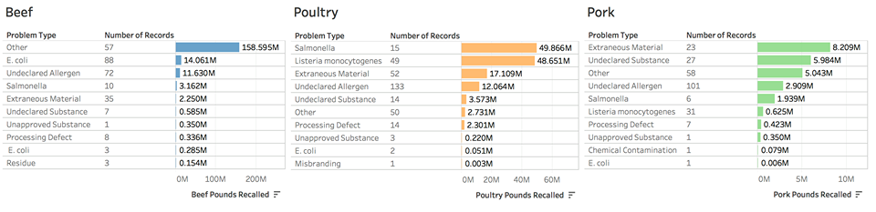

Although the figure under ‘other’ for beef seems high, this is again due to the Hallmark/Westland incident

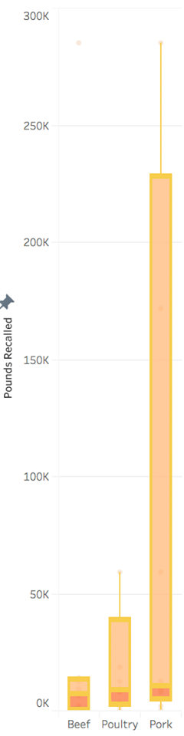

Pricings & Limitations

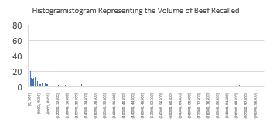By analyzing the ‘FSIS Recall_standardized.csv’ data, a processed dataset made from FSIS data, we aimed to estimate the normal size of meat recall events. Using a box plot we found the upper ‘whisker’ (a limit which falls within 1.5 times the interquartile range above the third quartile). Points above this are regarded as outliers (a conventional rule in statistics).

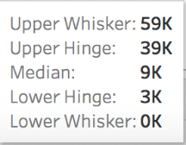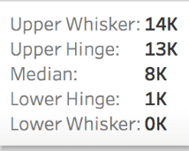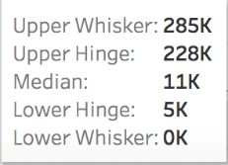

Beef

Poultry

Pork

Figures above these upper whiskers are considered outliers, i.e. a recall requiring more than 14,000 lbs of beef to be recalled would be very unusual. Therefore, it would be wise for an insurer to set an acceptable limit equal to the upper whisker. We could also define any recall above the ‘upper hinge’ a large incident and anything below it a small/reasonably sized incident.

The above histogram gives a visual representation of the size of a recall.

Pounds Recalled

Hence, underwriters can adopt a quantity limitation policy when formulating a meat recall product package, avoiding some unexpected risk. Assuming a linear relationship between the size of a recall and its cost, any payout from a recall above the acceptable limit can be calculated using: (Total claimed costs or losses) X (Upper whisker) / (Pounds of meat recalled)

This formula also assumes that the separate business interruption limit has not been met.

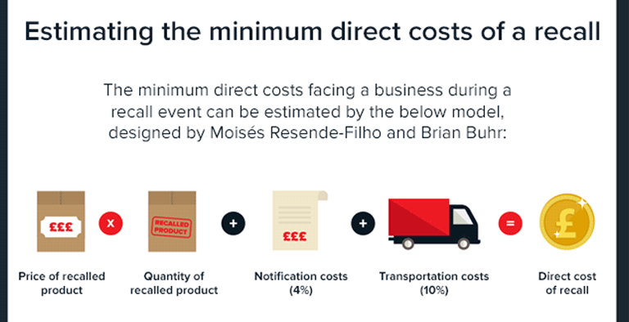

The price of the policy, of course, depends on the size of the business and the amount of meat which is exported. It therefore may be wise to include a sliding scale premium in the policy, to account for an increase in exports after the manufacturer has ‘tested the water’.

It is estimated that the direct costs of a recall could account for only 20% of overall costs [13]; the other 80% of indirect costs could be higher in this scenario, given the potential for Chinese consumers to be scared away from US beef. As a result, it may be too risky to cover any reduction in sales due to a recall event; this keeps costs closer to the model [13] (right), plus business continuity costs which are not included in this model. This extra cost should be predicted using information from records, provided by the policy holder, calculated by: (hours of downtime) X (average cost of an hour of normal operations).

Observing the inter quartile range, the box plot (above right) clearly shows how much more predictable beef is in comparison to poultry and pork products. This lower risk and generally lower size of recalls means that an insurer must charge a lower premium in comparison to pork and poultry insurance products. This means there would be less profit on each individual sale of the insurance product; however, if the package is created and marketed correctly, or perhaps included as a subsection to a more encompassing package, the lower profit from an individual sale can be improved upon by the volume of products sold in this new, emerging market.

References

[1] N/A, Wikipedia, N/A, ‘Westland Meat Packing Company’ [Online]. Available:

<https://en.wikipedia.org/wiki/Hallmark/Westland_Meat_Packing_Company>

[2] T. Watkins, CNN, Aug 2011, ‘Cargill recalls 36 million pounds of ground turkey’ [Online]. Available:

<http://edition.cnn.com/2011/HEALTH/08/03/turkey.recall/index.html>

[3] J. Emmert, FSIS, Dec 2016, ‘National Steak and Poultry Recalls Ready-To-Eat Chicken That May Be Undercooked’ [Online]. Available:

<https://www.fsis.usda.gov/wps/portal/fsis/topics/recalls-and-public-health-alerts/recall-case-archive/archive/2016/recall-115-2016-expanded>

[4] K. Welshans, Feedstuffs, May 2017, ‘LIVESTOCK MARKETS: USDA forcasts 2.3% growth in 2018 beef production’ [Online]. Available:

<http://www.feedstuffs.com/markets/livestock-markets-usda-forecasts-23-growth-2018-beef-production>

[5] N/A, Rise of the Vegan, June2017, ‘Veganism has grown 500% since 2014 in the US’ [Online]. Available:

<https://www.riseofthevegan.com/blog/veganism-has-increased-500-since-2014-in-the-us>

[6] D. Fusaro, Food Processing, June 2018, ‘Millennials Spend More on Prepared Foods, Past and Sweets’ [Online]. Available:

<https://www.foodprocessing.com/industrynews/2018/millennials-spend-on-prepared-foods/>

[7] K. Good, agfax, Oct 2017, ‘Livestock Market: China’s Meat and Poultry Import Forecast, 2018’ [Online]. Available:

<https://agfax.com/2017/10/16/livestock-market-chinas-meat-and-poultry-import-forecast-2018/>

[8] N/A, Wikipedia, N/A, ‘Cultured Meat’ [Online]. Available:

<https://en.wikipedia.org/wiki/Cultured_meat>

[9] B. Jones, Futurism, Sept 2017, ‘China Signed a $300 Million Lab-Grown Meat Deal with Israel’ [Online]. Available:

<https://futurism.com/china-signed-a-300-million-lab-grown-meat-deal-with-israel/>

[10] J. Lui, K. Wills, S. Niu, Bloomberg, Aug 2017, ‘U.S. Beef Is Back on China’s Shelves -But China Doesn’t Care’ [Online]. Available:

<https://www.bloomberg.com/news/articles/2017-08-03/trump-s-vaunted-return-of-u-s-beef-to-china-risks-turning-a-dud>

[11] P. Case, Farmers Weekly, Feb 2018, ‘China to lift 20-year ban on British beef’ [Online]. Available:

<http://www.fwi.co.uk/business/china-to-lift-20-year-ban-on-british-beef.htm>

[12] D. Brown, Washington Post, Feb 2008, ‘USDA Orders Largest Meat Recall in U.S. History’ [Online] Available:

<http://www.washingtonpost.com/wp-dyn/content/article/2008/02/17/AR2008021701530.html>

[13] H. Wood, debugged, July 2017, ‘The cost of product recalls to food business’ [Online]. Available:

<https://www.rentokil.com/blog/the-cost-of-product-recalls-to-food-businesses/#.Wps98ujFLIW>